Module(CSS and CSS-3)-2

**Que 1 : What are the benefits of using CSS?**

**Ans :** CSS means cascading stylesheet.

* Complex task become easy with CSS, we can add different effect, colour, animation, design for better user experience.
* We get easy formatting, if changes are made in one page it automatically applies to all pages rather changing in all pages.
* This helps to add design in simple html web page and add styling to it.
* There are advance things like flex, grid, transform help to create more flexible and responsive design

**Que 2 : What are the disadvantages of CSS?**

**Ans** : CSS is a powerful styling language used to define the presentation of web pages. While it offers many advantages, it also has its disadvantages.

* **Complexity**: CSS can become complex, especially in large-scale projects or when trying to achieve intricate designs. Managing stylesheets with numerous rules and dependencies can be challenging, leading to code maintainability issues.
* **Performance**: Poorly optimized CSS files can negatively impact website performance, leading to longer load times and increased bandwidth usage. This is particularly important for mobile devices and users with slower internet connections
* **Browser Compatibility**: One of the most significant challenges with CSS is ensuring consistent rendering across different web browsers. Some CSS properties may behave differently or not be supported at all in certain browsers, leading to inconsistencies in the appearance of a website.
* **Specificity and Cascading**: The cascade and specificity rules of CSS can sometimes make it difficult to predict how styles will be applied. This can lead to unexpected styling behaviour, especially when dealing with conflicting style rules or inheritance.

**Que 3 : What is the difference between CSS2 and CSS3?**

**Ans :** CSS has evolved over time, with CSS2 and CSS3 being significant milestones. Here are the key differences between CSS2 and CSS3

1. **New Features**: CSS3 introduced many new features and enhancements over CSS2. Some notable additions include:
   * **Media Queries**: Allows for responsive web design by applying styles based on the characteristics of the device or viewport.
   * **Box Shadow and Border Radius**: Allows for easy creation of rounded corners and shadow effects on elements.
   * **Selectors**: Introduces advanced selectors like attribute selectors, nth-child selectors, and more, providing more flexibility in targeting elements.
   * **Flexbox and Grid Layout**: Introduces powerful layout systems for creating complex and responsive layouts with ease.
   * **Transitions and Animations**: Enables the creation of smooth transitions and animations using CSS, reducing the reliance on JavaScript for simple animations.
2. **Browser Support**: CSS2 is widely supported across all modern browsers, while CSS3 features have varying levels of support depending on the feature and the browser. However, with time, browser support for CSS3 features has improved significantly.
3. **Compatibility**: CSS3 is designed to be backward compatible with CSS2, meaning CSS2 styles should work correctly in CSS3-compliant browsers. However, some CSS3 features may not be supported in older browsers, requiring fallbacks or alternative approaches for graceful degradation

**Que 4: Name a few CSS style components?**

**Ans :** Here are a few common CSS style components.

1. **Color and Backgrounds**: CSS allows you to define colors for text, backgrounds, borders, and other elements using properties like color, background-color, background-image, background-repeat, background-position, and background-size.
2. **Layout**: CSS provides various layout techniques to arrange elements on a webpage. This includes traditional layout methods like floats, newer layout systems like Flexbox and Grid Layout, and positioning properties like position, display, and z-index.
3. **Box Model**: The box model comprises properties that control the layout and spacing of elements. This includes properties like width, height, padding, border, and margin.
4. **Selectors**: Selectors are used to target specific elements in a document for styling. CSS offers a wide range of selectors, including element selectors, class selectors, ID selectors, attribute selectors, pseudo-classes, and pseudo-elements.
5. **Responsive Design**: With the rise of mobile devices, responsive design has become crucial. CSS offers features like Media Queries and viewport-related properties (e.g., vw, vh) to create designs that adapt to different screen sizes and orientations.
6. **Flexibility and Alignment**: CSS provides properties to control the alignment and spacing of elements within a layout. This includes properties like align-items, justify-content, align-self, and align-content in Flexbox, as well as align-items, justify-items, align-content, and justify-content in Grid Layout.
7. **Transitions and Animations**: CSS allows you to create smooth transitions and animations to enhance user experience. Properties like transition, transform, and animation are used to define motion effects on elements.

**Que 5 : What do you understand by CSS opacity?**

Ans: CSS opacity refers to the transparency level of an element on a webpage. It allows you to control how opaque or transparent an element and its content are.

The opacity property in CSS can take values ranging from 0 to 1, where:

* 0 represents fully transparent (invisible)
* 1 represents fully opaque (fully visible)

**Example:**

transparent-box { opacity: 0.5; }

**Que 6: How can the background color of an element be changed?**

**Ans** : To change background color of element we have some

Background properties in CSS like.

**Example :**

.box{

Background-color: blue;

}

You can also use the **background** shorthand property to specify additional background-related properties, such as background image, background position, background repeat, and more, all in one declaration.

**Que 7: How can image repetition of the backup be controlled?**

**Ans : Ans:** In CSS, you can control the repetition of a background image using the background-repeat property. This property allows you to specify whether and how a background image should repeat both horizontally and vertically. There are several values you can use:

* **repeat**-x: The background image is repeated only horizontally (along the x-axis).
* **repeat-y**: The background image is repeated only vertically (along the y-axis).
* **repeat**: The background image is repeated both horizontally and vertically. This is the default value if the property is not specified.
* **no-repeat:** The background image is not repeated at all

**Que 8 : What is the use of the background-position property?**

**Ans :** The **background-position** property can take various values, including keywords, percentages, and length units. Here are some common ways to use **background-position**.

The **background-position** property in CSS allows you to control the positioning of a background image within its containing element. It specifies the starting position of the background image relative to the element's padding box.

* **Percentages**: You can specify the position using percentages, where **0%** represents the left/top edge of the element, and **100%** represents the right/bottom edge. For example, **background-position: 50% 50%;** will center the background image horizontally and vertically within the element.
* **Keywords**: You can use keywords like **top**, **bottom**, **left**, **right**, and **center** to position the background image relative to the element.
* **Length Units**: You can also use length units like pixels (**px**) to specify the position. For example, **background-position: 10px 20px;** will position the background image 10 pixels from the left edge and 20 pixels from the top edge of the element.

**Que 9 : Which property controls the image scroll in the background?**

**Ans :**  The property that controls the scrolling behaviour of a background image is called **background-attachment**. It determines whether a background image scrolls with the content of an element or remains fixed in place.

There are two main values for the **background-attachment** property.

* **fixed**: The background image remains fixed in place relative to the viewport, so it does not move when the content is scrolled. This creates a "parallax" effect, where the background appears to be stationary while the content scrolls over it.
* **scroll**: The background image scrolls along with the content as the user scrolls the webpage. This is the default behaviour.

**Que 10 : Why should background and color be used as separate properties?**

**Ans :** Using **background** and **color** as separate properties allows for more granular control over the styling of elements.

* **Flexibility and Modularity**: By using separate properties, you can independently adjust the background and text color without affecting each other. This provides greater flexibility in styling elements and allows for easier modification of individual properties without having to modify the entire **background** property.
* **Specificity and Inheritance**: Separating **background** and **color** properties can help prevent unintended styling conflicts and inheritance issues. For example, if you set both the **background** and **color** within the **background** property, any subsequent changes to the **background** property may inadvertently affect the text color as well. Separating them ensures that each property is targeted explicitly.
* **Clarity and Readability**: Separating **background** and **color** properties makes the CSS code more readable and easier to understand. It clearly separates the styling of the background from the text color, improving code maintainability and making it easier for other developers to comprehend.
* **Performance**: Although the performance impact is minimal, separating **background** and **color** properties may slightly improve rendering performance since the browser doesn't need to parse and compute combined shorthand properties.

**Que 11: How to center block elements using CSS1?**

**Ans :**

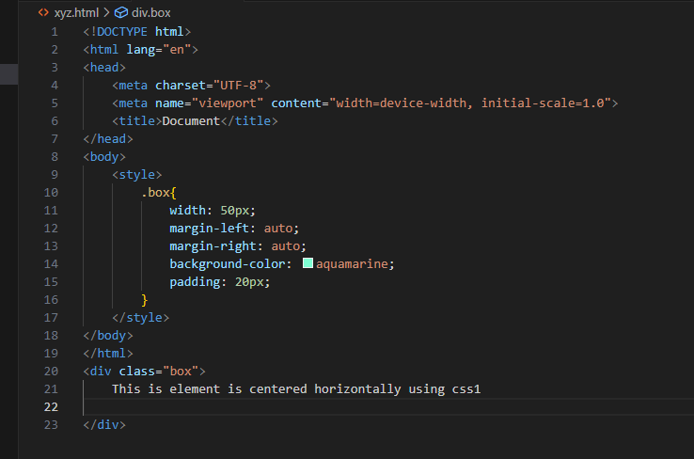

**Explanation :**

* Set left and right margins to **auto**. This automatically distributes the remaining space equally on both sides of the element, effectively centering it horizontally.
* Set a fixed width for the block element using the **width** property.

**Que 12 : How to maintain the CSS specifications?**

**Ans :**  Maintaining CSS specifications involves several key practices to ensure consistency, clarity, and compatibility across different projects and teams. Here are some guidelines for maintaining CSS specifications effectively:

* **Version Control**: Store CSS files in a version control system (such as Git) to track changes, collaborate with team members, and revert to previous versions if needed. Use meaningful commit messages to describe changes accurately.
* **Documentation**: Document CSS specifications comprehensively, including guidelines, naming conventions, coding standards, best practices, and usage examples. Make the documentation easily accessible to all team members and keep it up-to-date as the project evolves.
* **Consistent Naming Conventions**: Establish and follow consistent naming conventions for CSS classes, IDs, variables, and other selectors. Consistent naming makes the codebase more maintainable and easier to understand for everyone involved.
* **Linting**: Use CSS linters (e.g., Stylelint) to enforce coding standards, catch errors, and ensure consistency in code style across the project. Configure linters to check for common mistakes, enforce naming conventions, and flag potential issues.
* **Linting**: Use CSS linters (e.g., Stylelint) to enforce coding standards, catch errors, and ensure consistency in code style across the project. Configure linters to check for common mistakes, enforce naming conventions, and flag potential issues.
* **Modularization**: Break CSS code into smaller, reusable modules or components to promote code reusability, scalability, and easier maintenance. Use techniques like BEM (Block Element Modifier) or other modular CSS methodologies to organize styles effectively.

**Que 13: What are the ways to integrate CSS as a web page?**

**Ans :**  There are several ways to integrate CSS into a web page. Here are some common methods:

* **Inline CSS**: You can include CSS directly within HTML elements using the **style** attribute. Inline CSS applies styles specifically to the element it's defined on. While inline CSS is easy to implement, it's generally not recommended for large-scale styling due to its lack of maintainability and separation of concerns.
* **Internal CSS**: Internal CSS involves placing CSS code within the **<style>** element in the **<head>** section of an HTML document. Internal CSS applies styles to the entire HTML document, allowing for better organization and maintainability compared to inline CSS.
* **External CSS**: External CSS involves linking an external CSS file to the HTML document using the **<link>** element in the **<head>** section. External CSS files can be reused across multiple HTML pages, promoting maintainability, scalability, and separation of concerns.

**Que 14: What is embedded style sheets?**

**Ans :** Embedded style sheets, also known as internal style sheets, involve placing CSS code directly within the **<style>** element in the **<head>** section of an HTML document. This method allows you to define styles specific to the HTML document without the need for external CSS files. Here's an example of embedded style sheets:

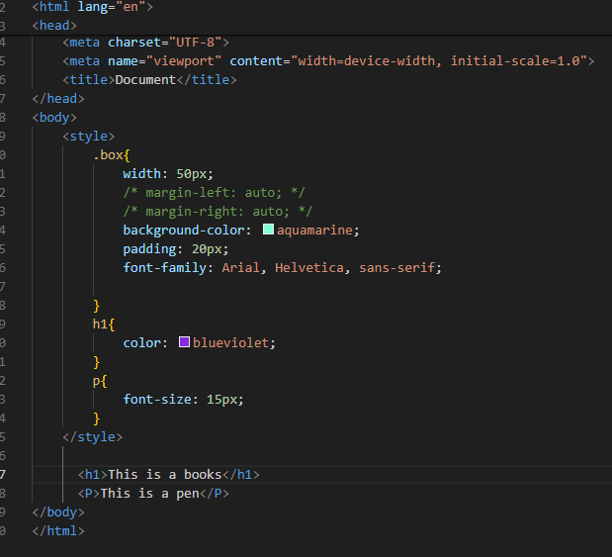

**Example understanding:**

* CSS rules are written following standard CSS syntax, with selectors targeting HTML elements and declarations specifying the styles to apply.
* The CSS styles are defined within the **<style>** element in the **<head>** section.
* The styles defined within the embedded style sheet apply only to the HTML document in which they are defined

**Que 15 : What are the external style sheets?**

**Ans :**  External style sheets involve placing CSS code in separate external files with a **.css** extension and linking them to HTML documents using the **<link>** element in the **<head>** section. This method allows you to define styles in reusable CSS files that can be shared across multiple HTML documents, promoting consistency, maintainability, and scalability. Here's how external style sheets work:

1. **Link CSS File to HTML**: Use the **<link>** element in the **<head>** section of an HTML document to link the external CSS file. Specify the path to the CSS file using the **href** attribute.
2. **Create a CSS File**: Write CSS code in a separate file with a **.css** extension. This file contains CSS rules defining the styles for HTML elements.

**In this example:**

* The **<link>** element in the **<head>** section of the HTML document links the **styles.css** file using the **href** attribute.
* The HTML document now applies the styles defined in the external style sheet to its elements.
* The CSS code is stored in a separate file named **styles.css**.

**External style sheets offer several benefits, including:**

* **Maintainability**: Centralizing CSS code in external files makes it easier to manage and update styles without modifying individual HTML documents.
* **Scalability**: External style sheets are well-suited for large-scale projects with multiple HTML pages, as they help maintain a modular and organized codebase.
* **Caching**: External CSS files can be cached by web browsers, leading to faster page load times and improved performance for subsequent visits.

**Que 16: What are the advantages and disadvantages of using external style sheets?**

**Ans:** Using external style sheets offers several advantages and disadvantages

**Advantages:**

* **Maintainability**: Centralizing CSS code in external files makes it easier to manage and update styles. You can make changes to the styles in one place and have them automatically applied to all linked HTML documents.
* **Separation of Concerns**: External style sheets promote separation of content and presentation, adhering to the principle of modularity and improving code maintainability. HTML documents focus on content, while CSS files handle styling.
* **Reusability**: External style sheets allow you to define styles once and apply them to multiple HTML documents. This promotes consistency in design and layout across a website.
* **Scalability**: External style sheets are well-suited for large-scale projects with multiple HTML pages. They help maintain a modular and organized codebase, making it easier to scale and maintain the project over time.
* **Caching**: External CSS files can be cached by web browsers, leading to faster page load times and improved performance for subsequent visits to the website.

**Disadvantages:**

* **Rendering Delay**: If external style sheets are linked in the **<head>** section of an HTML document, the browser may wait to render the content until the CSS files are loaded. This can lead to a delay in displaying the page content, especially on slower network connections.
* **Additional HTTP Requests**: Each external style sheet linked to an HTML document requires an additional HTTP request, which can slightly increase page load times, especially for websites with multiple CSS files.
* **Complexity**: Managing multiple external CSS files across a large project can become complex and challenging, especially if there are dependencies or conflicts between styles.
* **Dependency**: HTML documents linked to external style sheets are dependent on the availability and proper functioning of those CSS files. If the external CSS file fails to load or is improperly linked, it can affect the styling of HTML documents.

**Que 17 : What is the meaning of the CSS selector?**

**Ans :** Here are some common types of CSS selectors

* **Class Selector**: Targets HTML elements based on their class attribute. For example, **.example** selects all elements with **class="example"**.
* **ID Selector**: Targets HTML elements based on their ID attribute. For example, **#header** selects the element with **id="header"**.
* **Element Selector**: Targets HTML elements based on their element type. For example, **p** selects all **<p>** elements.
* **Descendant Selector**: Targets elements that are descendants of another element. For example, **div p** selects all **<p>** elements that are descendants of **<div>** elements.
* **Attribute Selector**: Targets HTML elements based on their attributes and attribute values. For example, **[type="text"]** selects all elements with **type="text"**.
* **Child Selector**: Targets elements that are direct children of another element. For example, **div > p** selects all **<p>** elements that are immediate children of **<div>** elements.
* **Pseudo-classes and Pseudo-elements**: Targets elements based on their state or position in the document. For example, **:hover** selects elements when they are hovered over by the mouse cursor, and **::before** creates a pseudo-element that inserts content before the content of the selected element.
* **Adjacent Sibling Selector**: Targets an element that is immediately preceded by a specified sibling element. For example, **h2 + p** selects all **<p>** elements that are immediately preceded by an **<h2>** element.

**Que 18: What are the media types allowed by CSS?**

**Ans :** CSS supports different media types, which allow styles to be applied based on the characteristics of the output device or media. The following are the media types allowed by CSS

* **braille**: Applies to braille tactile feedback devices.
* **handheld**: Applies to handheld devices like smartphones and small tablets.
* **speech**: Applies to speech synthesizers, like screen readers. This is used to create styles for users who may be accessing the content through auditory means.
* **screen**: Applies to computer screens, tablets, smart-phones, and similar devices with a color screen.
* **all**: Applies to all devices.
* **print**: Applies to paged material and documents viewed in print preview mode. This is often used to style the appearance of printed pages.
* **projection**: Applies to projectors.
* **embossed**: Applies to paged braille printers.

**Que 19: What is the rule set?**

**Ans :** Here's the general syntax of a CSS rule set

Let's break down the components of a CSS rule set

* **Properties and Values**: Within the declaration block, properties represent the styling attributes (e.g., **color**, **font-size**, **background-color**), while values specify the desired styling values for those properties (e.g., **blue**, **16px**, **#f0f0f0**). Multiple properties and values can be included within the same declaration block, each separated by a semicolon**;**.
* **Selector**: Specifies which HTML elements the rule set applies to. Selectors can target elements based on various criteria, such as element type, class, ID, attributes, and relationships with other elements.
* **Declaration Block**: Enclosed within curly braces **{}** following the selector, the declaration block contains one or more declarations. Each declaration consists of a property and its corresponding value, separated by a colon **:**.